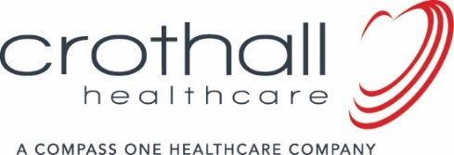
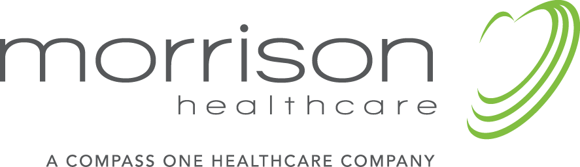

FOR IMMEDIATE RELEASE

Contact: Angela Hong
Communications Manager
Compass One Healthcare
404-236-7871
angelahong@iammorrison.com

Morrison Healthcare and Crothall Healthcare Named Two of Modern Healthcare’s Best Places to Work in Healthcare for 2017

Compass One Healthcare companies named to prestigious list honoring workplaces throughout the healthcare industry that empower employees to provide patients and customers

with the best possible care, products and services.

ATLANTA, GA and WAYNE, PA (May 22, 2017) – Morrison Healthcare and Crothall Healthcare have been selected as two of Modern Healthcare’s Best Places to Work in Healthcare for 2017. Compass One Healthcare is comprised of Morrison Healthcare food and nutrition services and Crothall Healthcare support services, which are part of Compass Group USA.

The two are among 100 healthcare companies named to the list, now in its tenth year. Morrison Healthcare has made the list six times and this marks Crothall’s fifth consecutive year winning the prestigious award.

“Modern Healthcare’s Top 100 validates the people culture we are building, that places value on enhancing patient experiences in the facilities we serve, as well as the health and wellness of our people and communities,” said Compass One Healthcare CEO Bobby Kutteh. “This recognition would not be possible without the genuine support we receive from our customers, whose great mission and cultures also engage our teams.”

Modern Healthcare’s Top 100 list recognizes employers for “creating a workplace that enables associates to perform at their optimum level and to provide patients and customers with the best possible care and services.” Companies are chosen based on employer and employee surveys.

About Compass One Healthcare
Compass One Healthcare is a premier healthcare company with 46,000 engaged team members who are focused on delivering quality, value, and exceptional patient experience through specialized services and protocols in more than 1,600 hospital and health system locations in 48 states. Through a combined three-quarters of a century of healthcare experience, Compass One offers seven customer-focused core services: Food and Nutrition, Environmental, Patient Transportation, Laundry & Linen, Healthcare Technology Solutions (Clinical Engineering), Facilities Management, and Ambulatory Services. Compass One is committed to the growth and development of its associates, and its unique Positive Impressions™ program features a team of 100-plus Patient Experience Managers dedicated to driving a better experience in each of our hospitals. Also, Compass One’s exclusive partnership with Press Ganey leverages rich analytics to better understand how to improve experiences for patients, family, customers, caregivers, and the community.

###

